SAP RAP-UNMANAGED-SCENARIO:
SAP RAP (ABAP RESTful Application Programming Model) has two main flavors: managed and unmanaged. Let's focus on the unmanaged version.
Unmanaged SAP RAP refers to a development approach where developers have more control over the data persistence and business logic compared to the managed approach. Here are some key aspects:
- Custom Logic: In unmanaged RAP, developers write their own custom logic for handling data retrieval, manipulation, and persistence. This gives more flexibility in how data is processed and stored.
- Direct Database Access: Developers can directly access the database tables and define their own data models using Core Data Services (CDS) views or ABAP classes.
- Explicit Service Definition: Unlike managed RAP, where service definitions are automatically generated based on annotations, unmanaged RAP requires developers to explicitly define service implementations and behaviors.
- Manual CRUD Operations: CRUD (Create, Read, Update, Delete) operations need to be implemented explicitly in unmanaged RAP, giving full control over how data is managed.
- Integration with Existing Systems: Unmanaged RAP is often used when integrating with existing systems or when there is a need for complex business logic that cannot be easily handled by the managed approach.
- Flexibility: Developers have more freedom to implement complex validation rules, authorization checks, and other custom requirements directly in the application logic.
Overall, unmanaged SAP RAP provides a more hands-on approach to application development compared to the managed approach, allowing developers to leverage their expertise in ABAP programming and database handling while building modern RESTful APIs.

CREATE A TABLE :
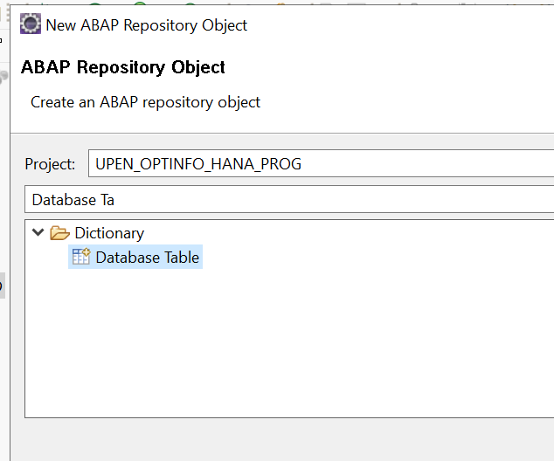

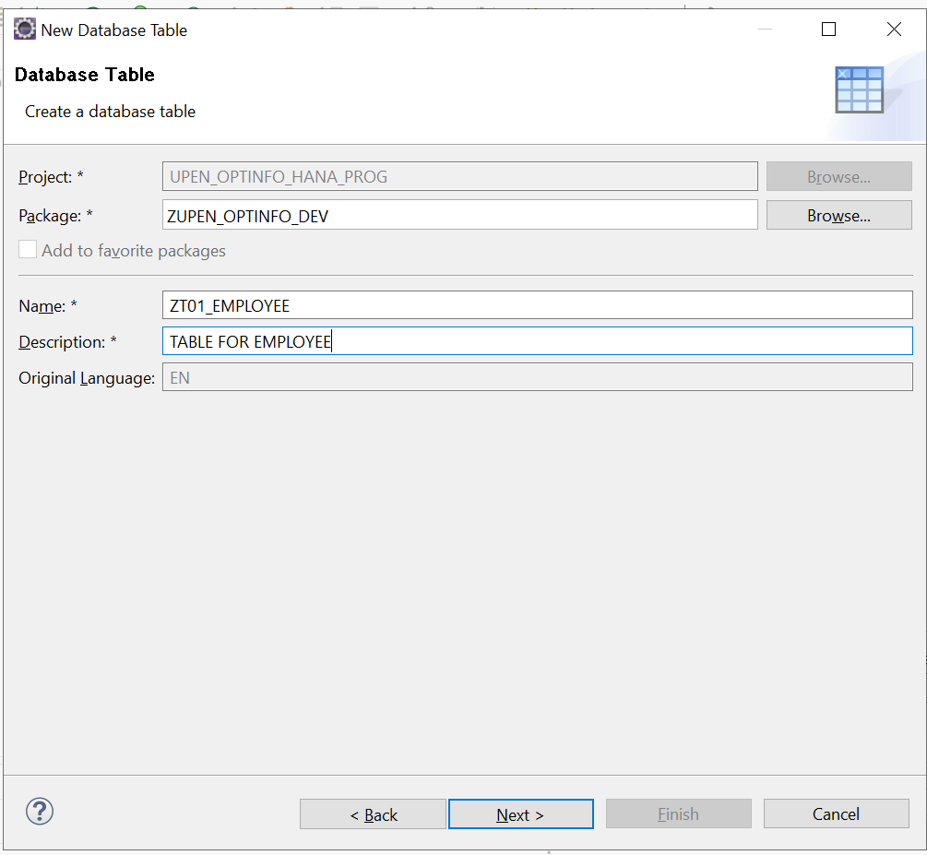
Give a name and description for the table and click on next
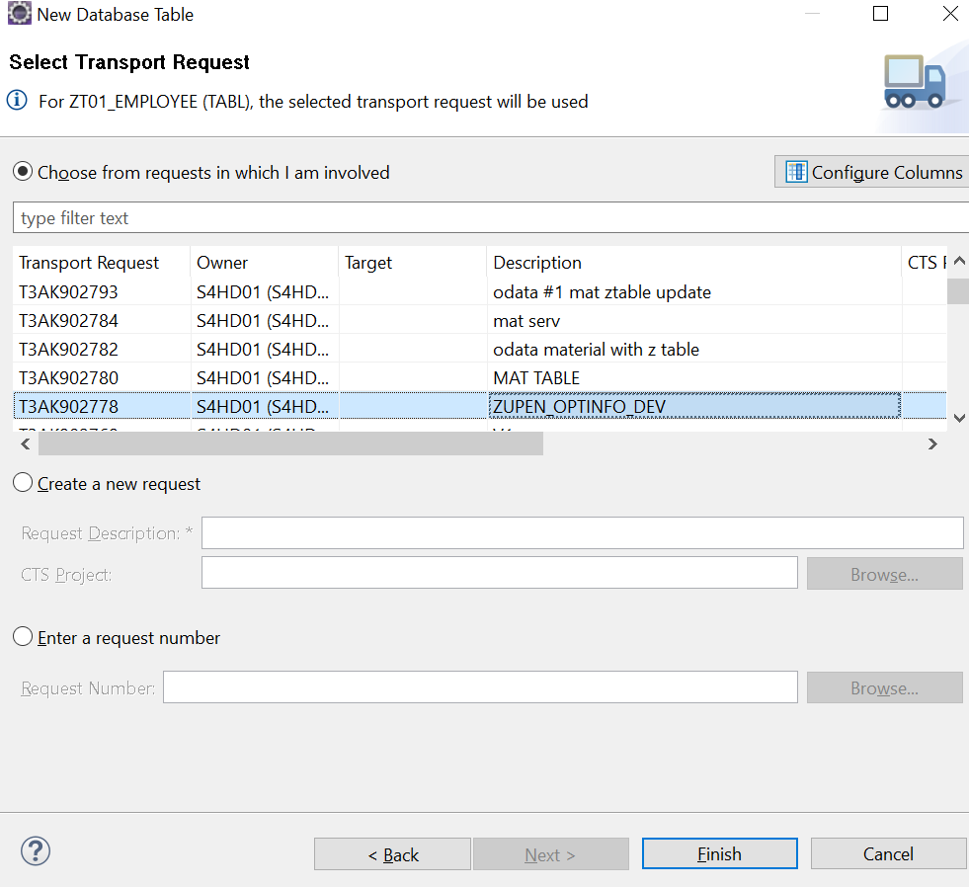
Select the tr and activate
source for the table :
@EndUserText.label : 'TABLE FOR EMPLOYEE'
@AbapCatalog.enhancement.category : #NOT_EXTENSIBLE
@AbapCatalog.tableCategory : #TRANSPARENT
@AbapCatalog.deliveryClass : #A
@AbapCatalog.dataMaintenance : #RESTRICTED
define table zt01_employee {

key client : abap.clnt not null;
key num : abap.dec(10,0) not null;
name : abap.char(20);
age : abap.dec(3 ,0);

}

Base CDS View Z_I_EMPLOYEES_U:

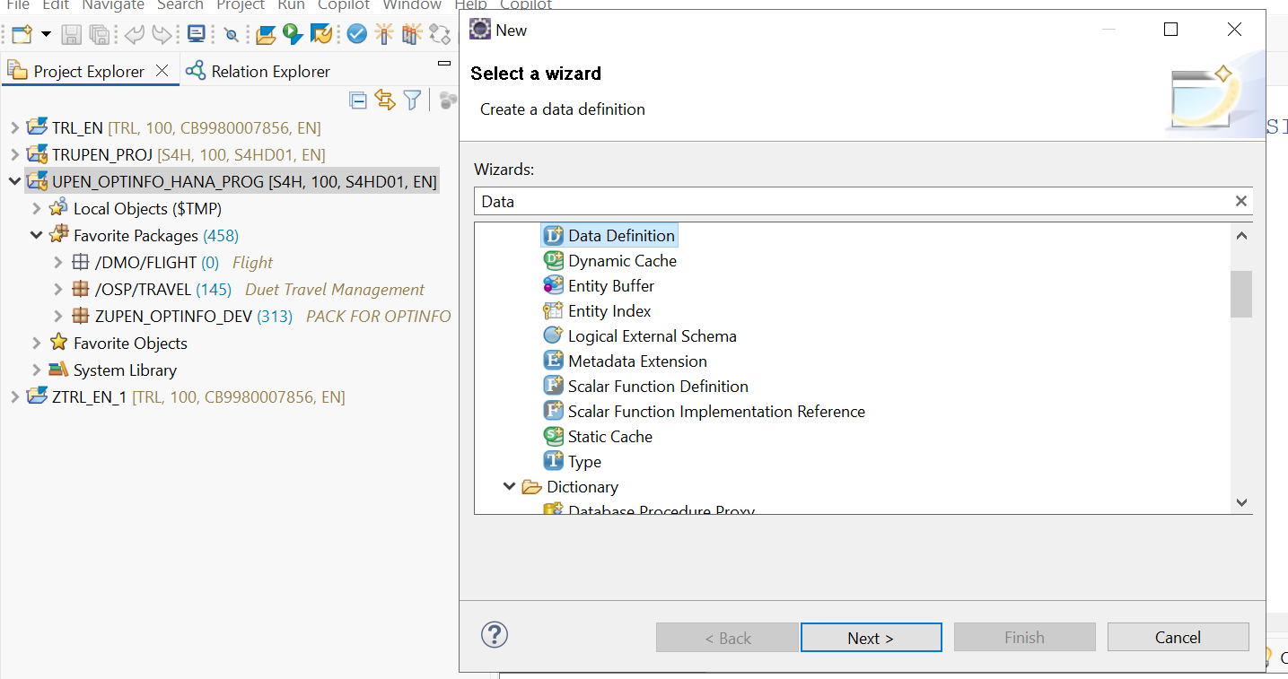

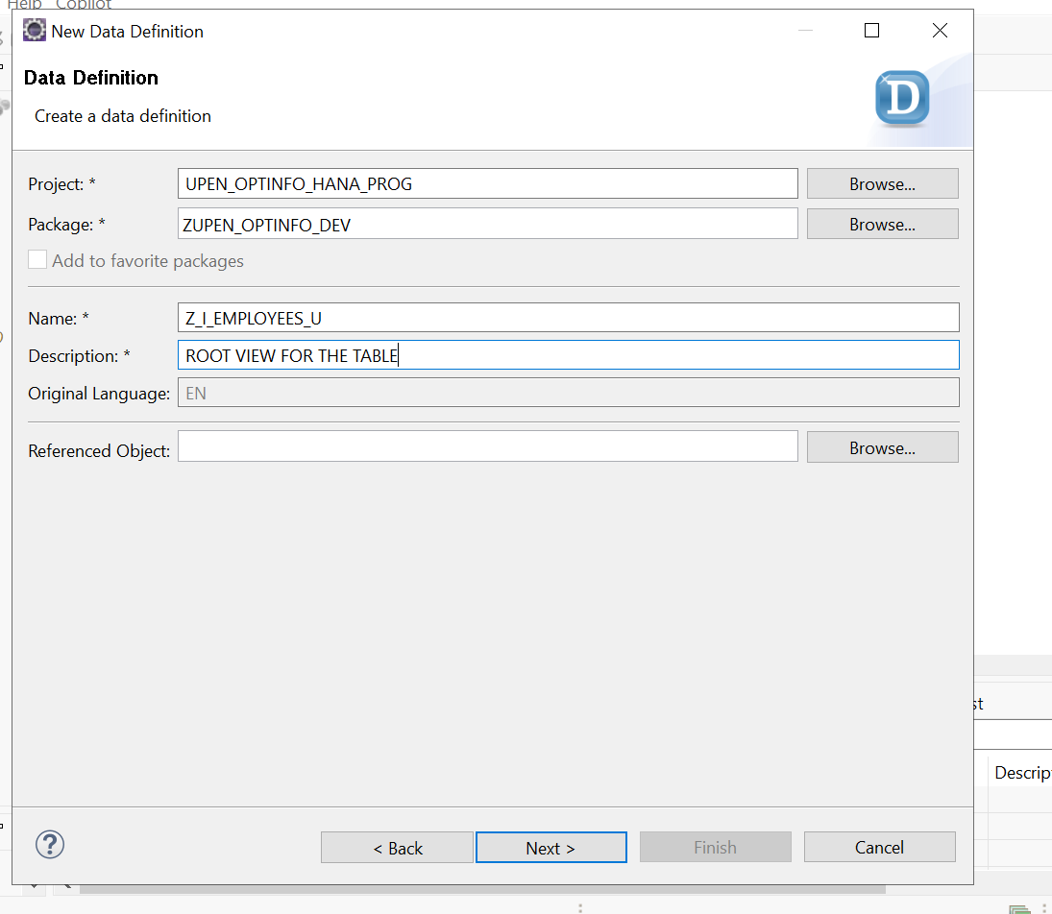
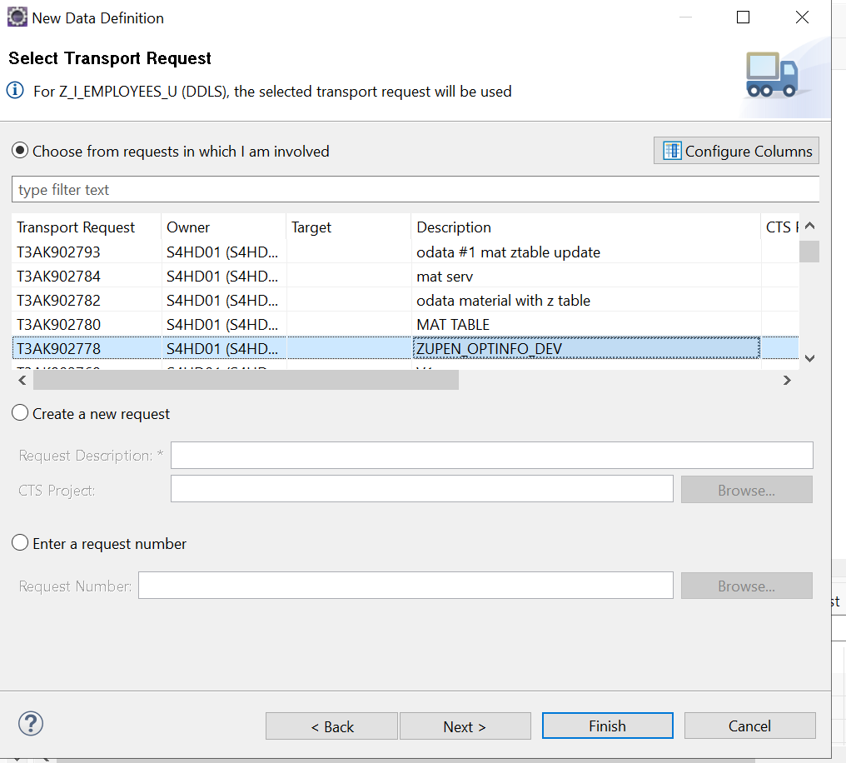

SOURCE CODE :
@AccessControl.authorizationCheck: #NOT_REQUIRED
@EndUserText.label: 'ROOT VIEW FOR THE TABLE'
@Metadata.ignorePropagatedAnnotations: true
define root view entity Z_I_EMPLOYEES_U as select from zt01_employee
{

key num as NUM,
name as Name,
age as Age

}

Consumtpiton view:
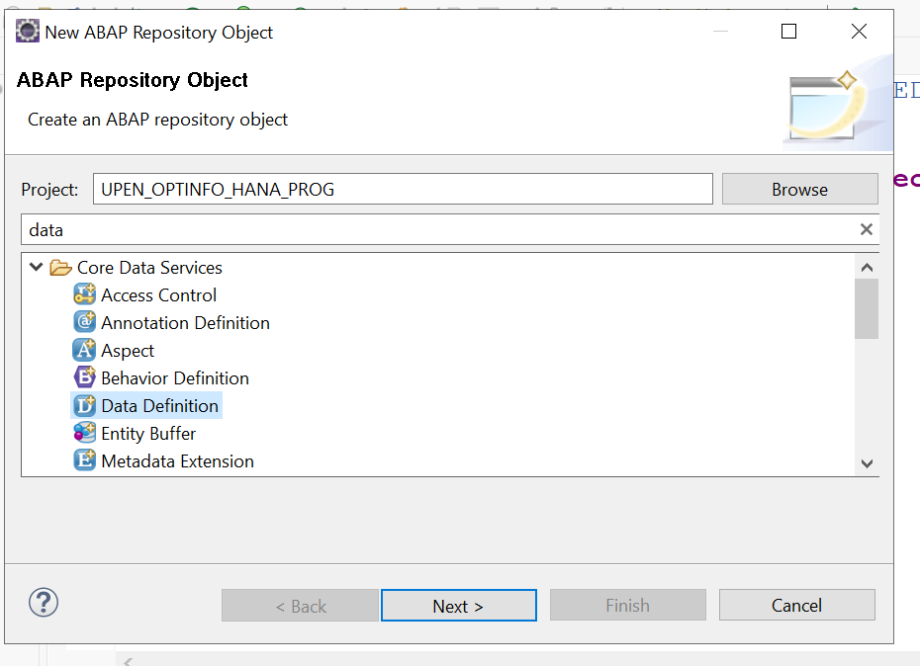
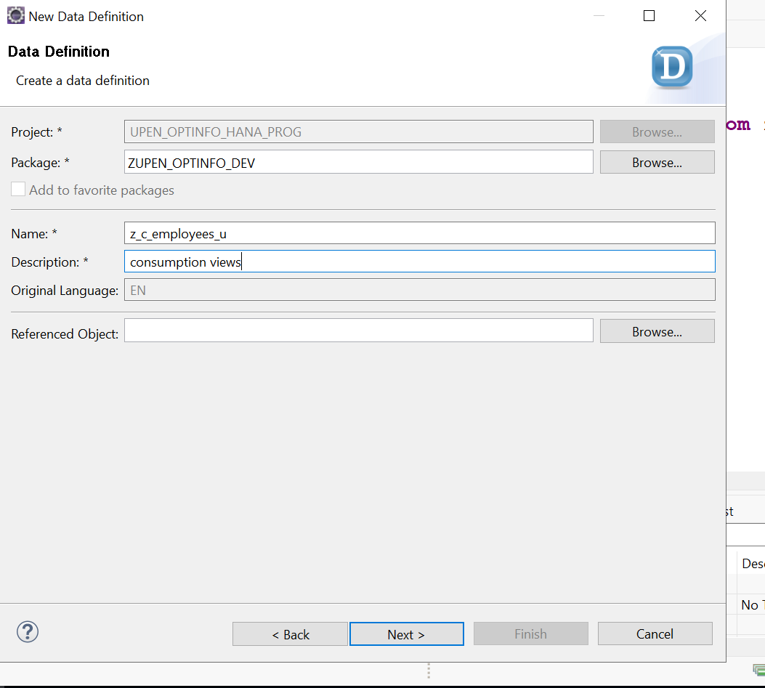

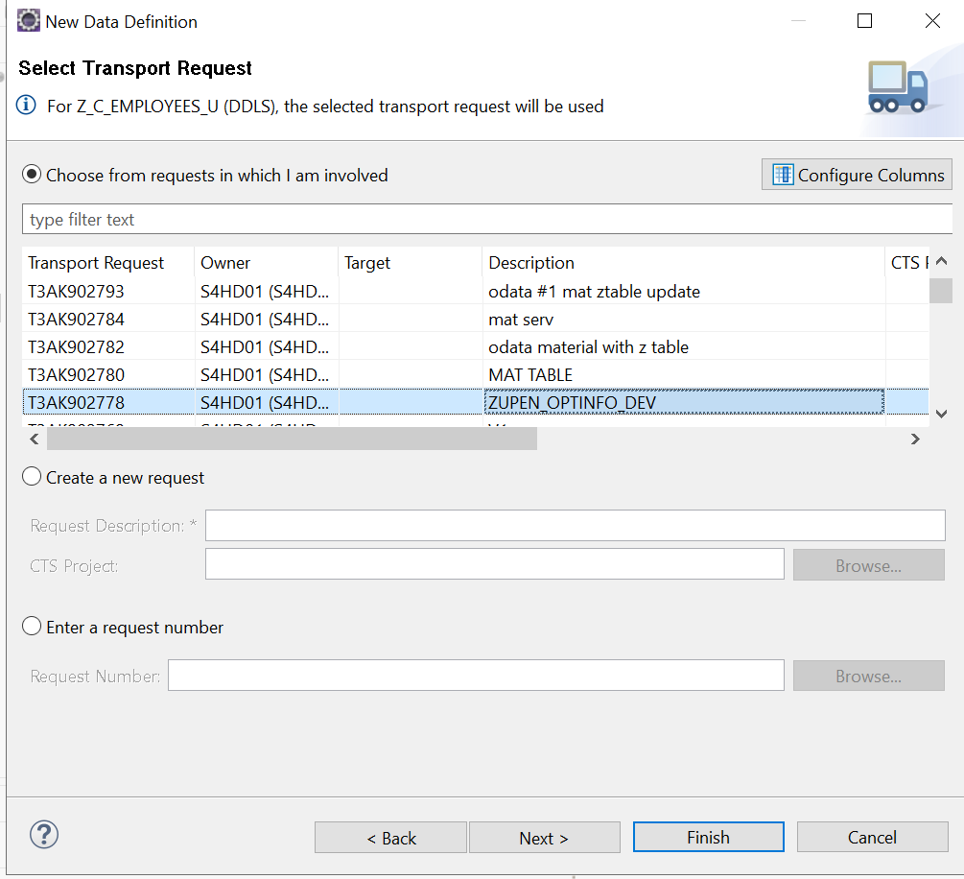
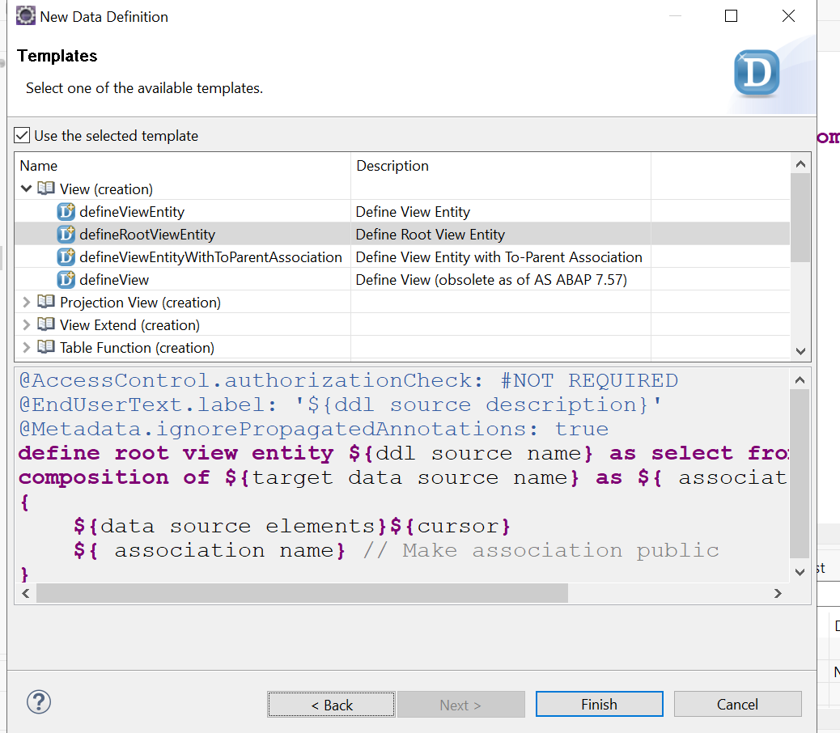
Source code :
@AccessControl.authorizationCheck: #NOT_REQUIRED
@EndUserText.label: 'consumption views'
@Metadata.ignorePropagatedAnnotations: true
@UI:{
headerInfo: { typeName : 'Employees',
typeNamePlural: 'Employees',
title: {type: #STANDARD, value: 'Name' } } }

define root view entity z_c_employees_u as projection on Z_I_EMPLOYEES_U
{
@EndUserText.label: 'Employee num'
@UI.facet: [{
label : 'General Information',
id : 'GeneralInfo',
purpose : #STANDARD,
position: 10,
type: #IDENTIFICATION_REFERENCE
}]

@UI.identification: [{
position : 10 }]
@UI.lineItem: [{ position : 10 }]
@UI.selectionField: [{ position : 10 }]
key NUM,
@EndUserText.label: 'Name'
@UI.identification: [{ position : 20 }]
@UI.lineItem: [{ position : 20 }]
@UI.selectionField: [{ position : 20 }]

Name,
@UI.identification: [{ position : 30 }]
@UI.lineItem: [{ position : 30 }]
@UI.selectionField: [{ position : 30 }]
Age

}

Behavior definition :
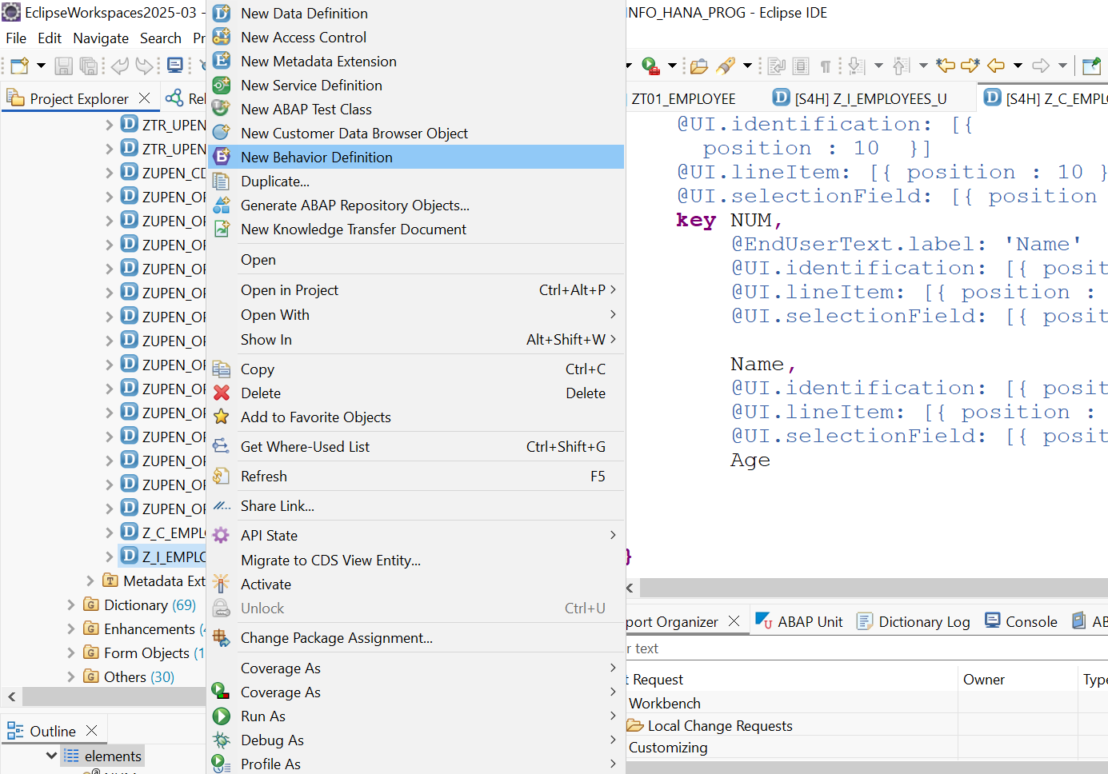

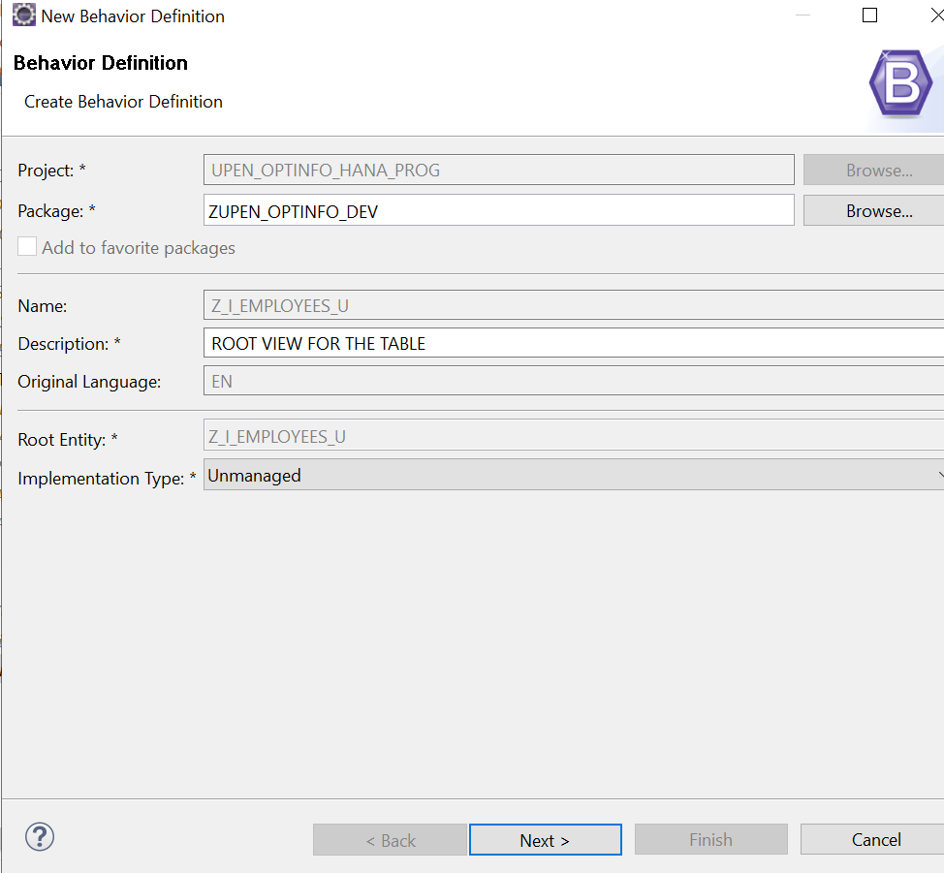

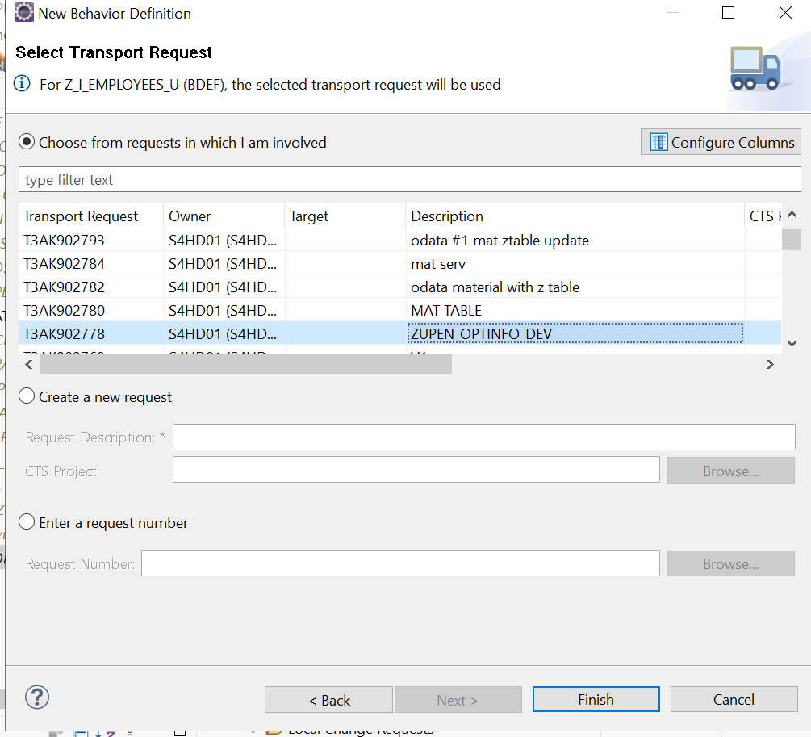

unmanaged implementation in class zbp_i_employees_u unique;
strict ( 2 );

define behavior for Z_I_EMPLOYEES_U //alias <alias_name>
//late numbering
lock master
authorization master ( instance )
//etag master <field_name>
{
create;
update;
delete;
field( readonly ) Num;
}

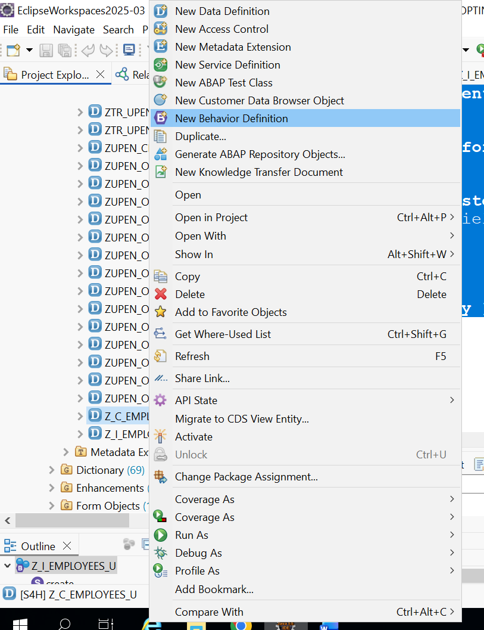

Create a behavior definition for the consumption view
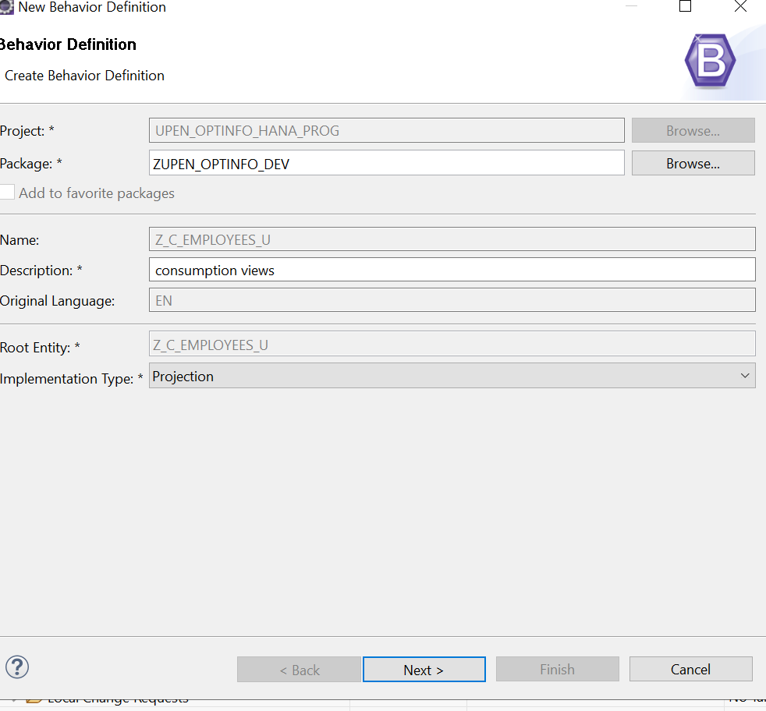

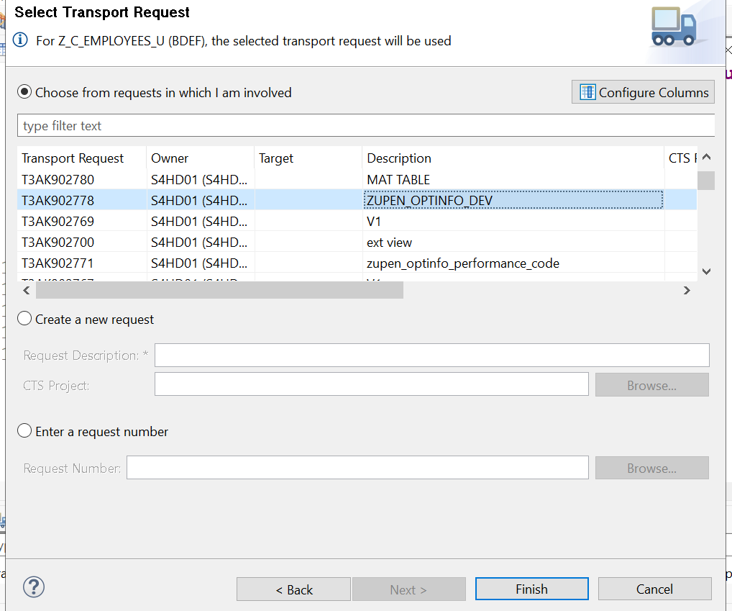

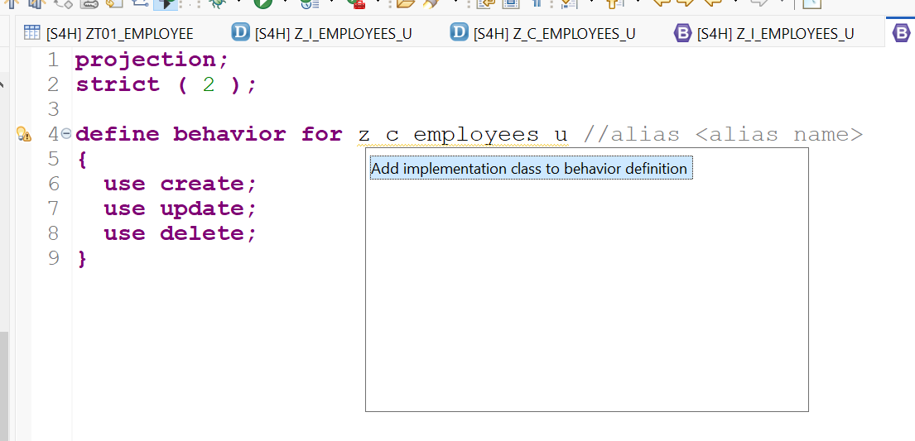

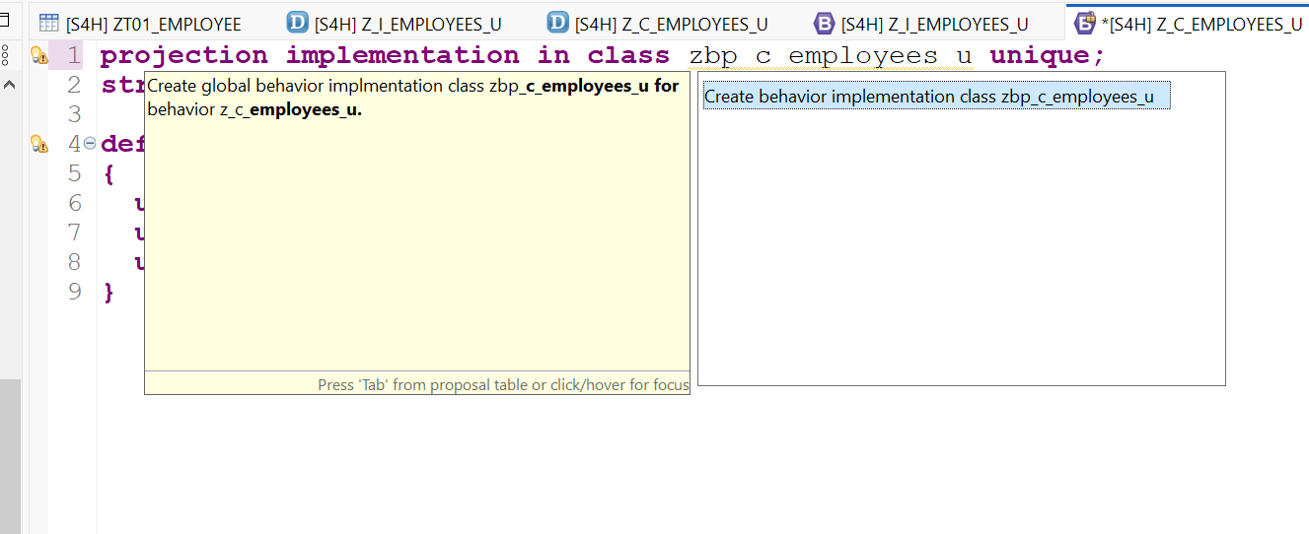

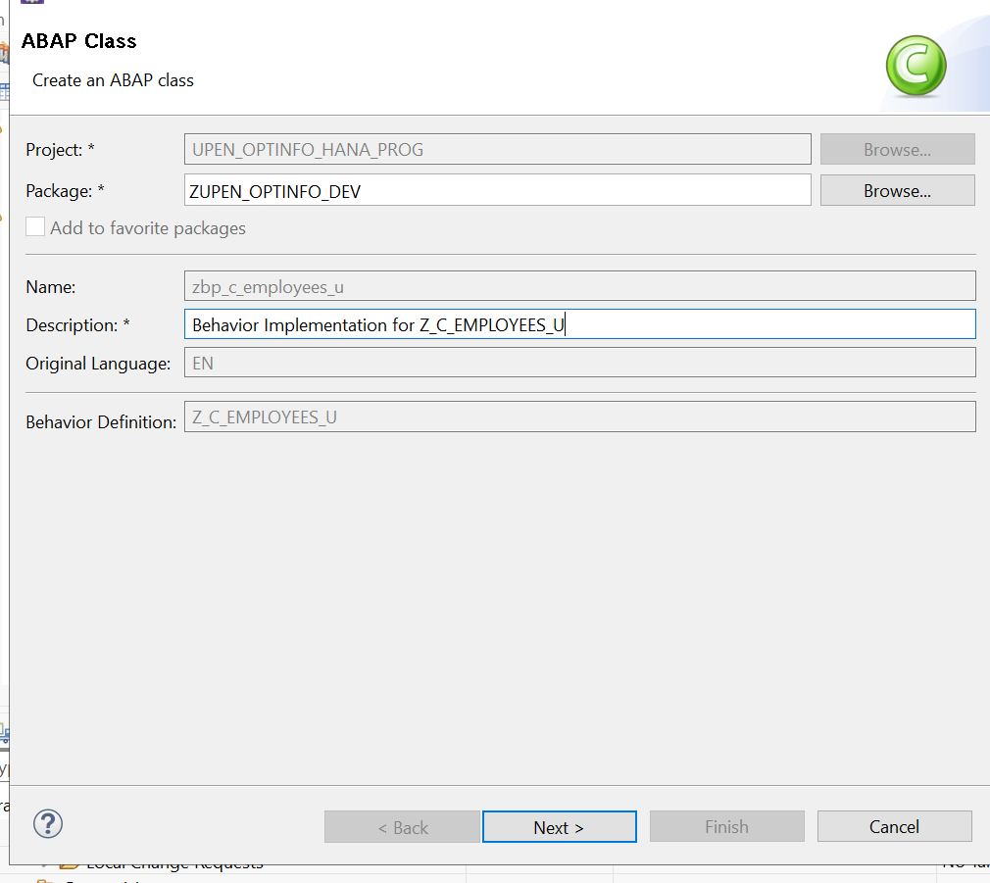
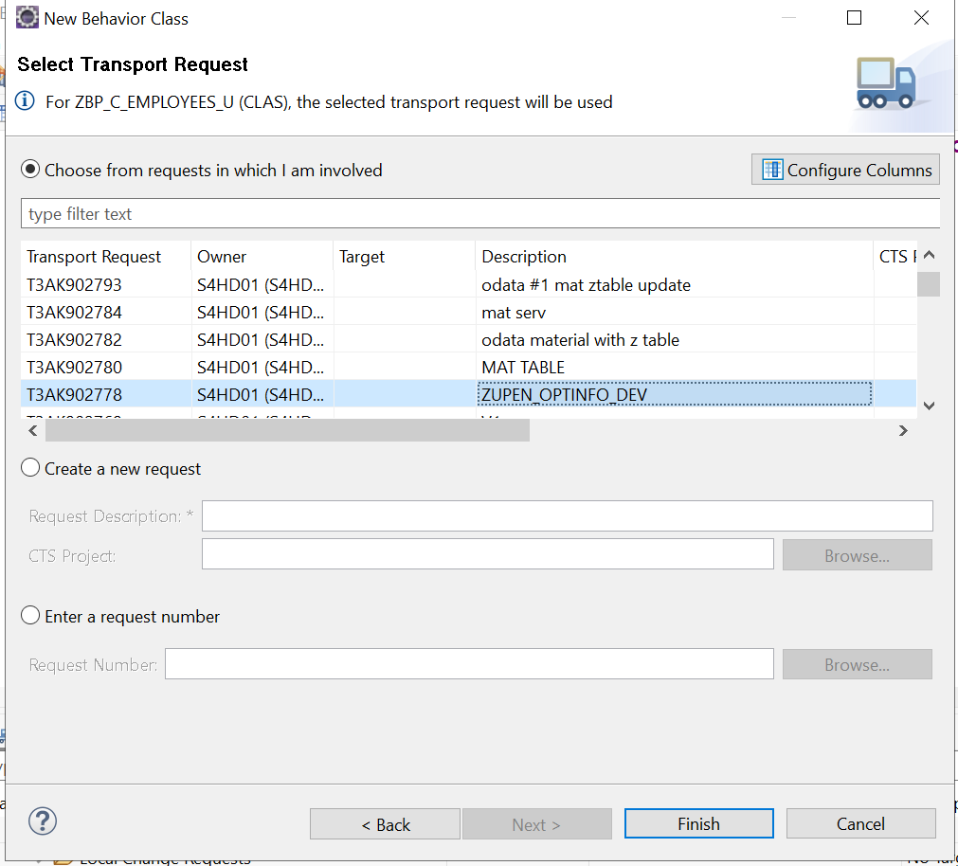

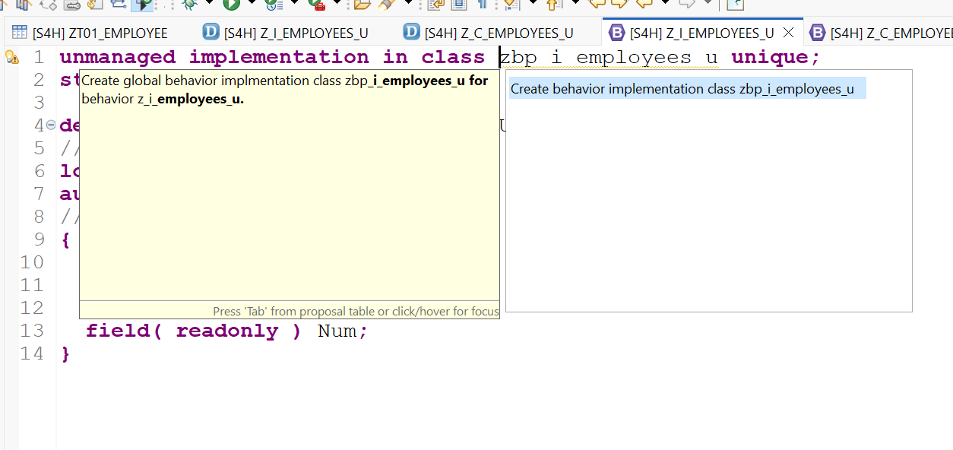
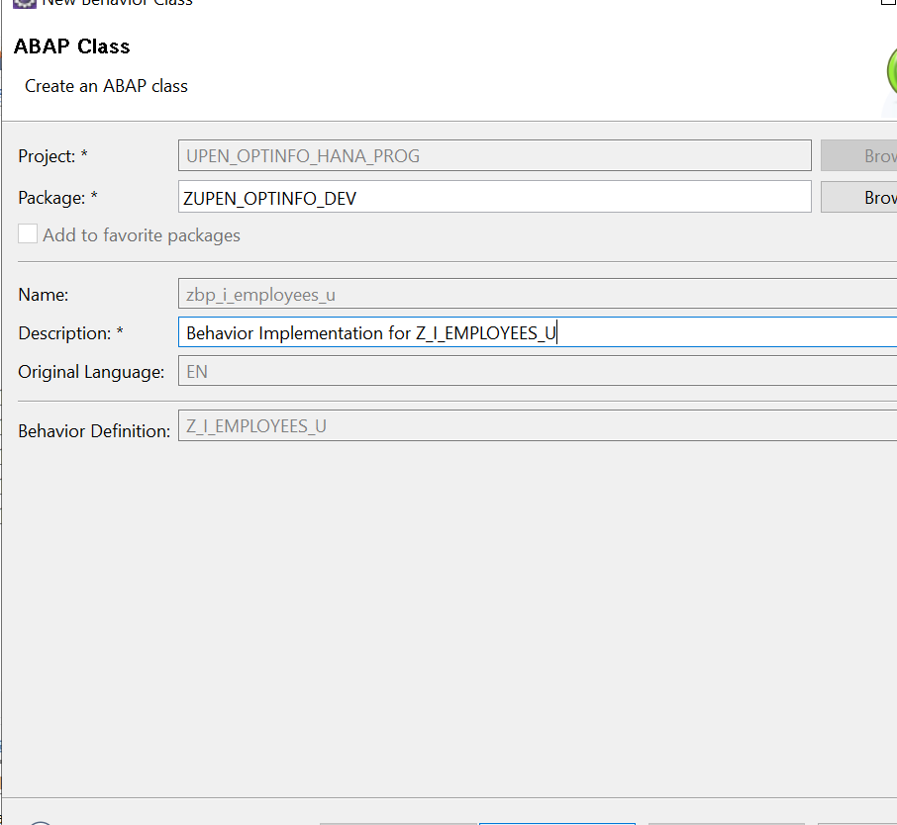
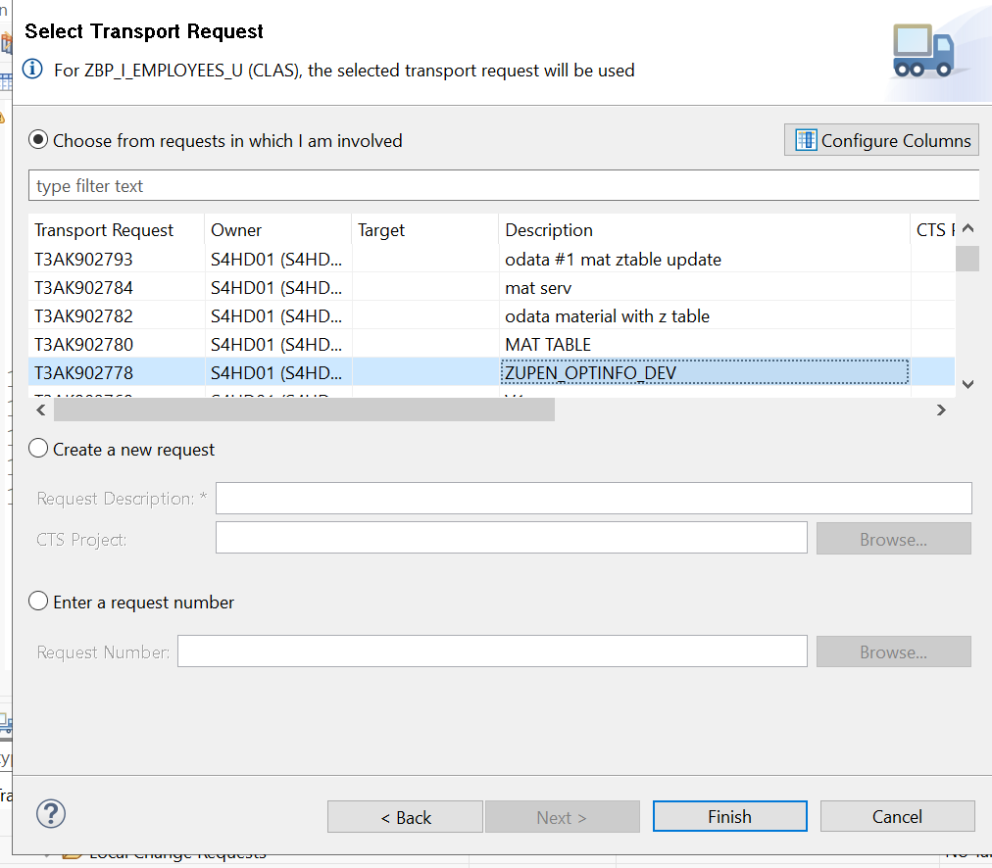

**********************************************************************
* 1. BUFFER CLASS (Stores transactional data before Save)
**********************************************************************
CLASS lcl_buffer DEFINITION CREATE PRIVATE.
PUBLIC SECTION.
CLASS-METHODS get_instance
RETURNING VALUE(ro_instance) TYPE REF TO lcl_buffer.

" MOVED TO PUBLIC: So the Saver class can strictly type the field symbols
" CHANGED: We now store %pid instead of %cid
TYPES: BEGIN OF ty_create,
pid TYPE abp_behv_pid, " Preliminary ID for Late Numbering
num TYPE zt01_employee-num,
name TYPE zt01_employee-name,
age TYPE zt01_employee-age,
END OF ty_create.

DATA: mt_create TYPE STANDARD TABLE OF ty_create WITH DEFAULT KEY,
mt_update TYPE STANDARD TABLE OF zt01_employee WITH DEFAULT KEY,
mt_delete TYPE STANDARD TABLE OF zt01_employee WITH DEFAULT KEY.

PRIVATE SECTION.
CLASS-DATA: go_instance TYPE REF TO lcl_buffer.
ENDCLASS.

CLASS lcl_buffer IMPLEMENTATION.
METHOD get_instance.
IF go_instance IS NOT BOUND.
go_instance = NEW #( ).
ENDIF.
ro_instance = go_instance.
ENDMETHOD.
ENDCLASS.

**********************************************************************
* 2. HANDLER CLASS (CRUD, Locks, Auth)
**********************************************************************
CLASS lhc_employee DEFINITION INHERITING FROM cl_abap_behavior_handler.
PRIVATE SECTION.
METHODS get_instance_authorizations FOR INSTANCE AUTHORIZATION
IMPORTING keys REQUEST requested_authorizations FOR employee RESULT result.

METHODS create FOR MODIFY
IMPORTING entities FOR CREATE employee.

METHODS update FOR MODIFY
IMPORTING entities FOR UPDATE employee.

METHODS delete FOR MODIFY
IMPORTING keys FOR DELETE employee.

METHODS read FOR READ
IMPORTING keys FOR READ employee RESULT result.

METHODS lock FOR LOCK
IMPORTING keys FOR LOCK employee.
ENDCLASS.

CLASS lhc_employee IMPLEMENTATION.
METHOD get_instance_authorizations.
ENDMETHOD.

METHOD create.
DATA(lo_buffer) = lcl_buffer=>get_instance( ).
DATA lv_pid TYPE abp_behv_pid.

LOOP AT entities INTO DATA(ls_entity).
" 1. Generate a Preliminary ID (%pid) for Late Numbering
TRY.
lv_pid = cl_system_uuid=>create_uuid_x16_static( ).
CATCH cx_uuid_error.
" Fallback handling
ENDTRY.

" 2. Store data in buffer using the PID
APPEND VALUE #( pid = lv_pid
name = ls_entity-name
age = ls_entity-age ) TO lo_buffer->mt_create.

" 3. Map the frontend's %cid to the framework's %pid
INSERT VALUE #( %cid = ls_entity-%cid
%pid = lv_pid ) INTO TABLE mapped-employee.
ENDLOOP.
ENDMETHOD.

METHOD update.
DATA ls_emp TYPE zt01_employee.
DATA(lo_buffer) = lcl_buffer=>get_instance( ).

LOOP AT entities INTO DATA(ls_entity).
SELECT SINGLE * FROM zt01_employee WHERE num = @ls_entity-num INTO @ls_emp.
IF sy-subrc = 0.
IF ls_entity-%control-name = if_abap_behv=>mk-on.
ls_emp-name = ls_entity-name.
ENDIF.
IF ls_entity-%control-age = if_abap_behv=>mk-on.
ls_emp-age = ls_entity-age.
ENDIF.

APPEND ls_emp TO lo_buffer->mt_update.
ENDIF.
ENDLOOP.
ENDMETHOD.

METHOD delete.
DATA ls_emp TYPE zt01_employee.
DATA(lo_buffer) = lcl_buffer=>get_instance( ).

LOOP AT keys INTO DATA(ls_key).
ls_emp-num = ls_key-num.
APPEND ls_emp TO lo_buffer->mt_delete.
ENDLOOP.
ENDMETHOD.

METHOD read.
IF keys IS NOT INITIAL.
SELECT * FROM zt01_employee FOR ALL ENTRIES IN @keys
WHERE num = @keys-num
INTO TABLE @DATA(lt_emp).

LOOP AT lt_emp INTO DATA(ls_emp).
INSERT VALUE #( num = ls_emp-num
name = ls_emp-name
age = ls_emp-age ) INTO TABLE result.
ENDLOOP.
ENDIF.
ENDMETHOD.

METHOD lock.
" Enqueue logic
ENDMETHOD.
ENDCLASS.

**********************************************************************
* 3. SAVER CLASS (Late Numbering & Database Commit)
**********************************************************************
CLASS lsc_z_i_employees_u DEFINITION INHERITING FROM cl_abap_behavior_saver.
PROTECTED SECTION.
METHODS finalize REDEFINITION.
METHODS check_before_save REDEFINITION.
METHODS adjust_numbers REDEFINITION.
METHODS save REDEFINITION.
METHODS cleanup REDEFINITION.
METHODS cleanup_finalize REDEFINITION.
ENDCLASS.

CLASS lsc_z_i_employees_u IMPLEMENTATION.
METHOD finalize.
ENDMETHOD.

METHOD check_before_save.
ENDMETHOD.

METHOD adjust_numbers.
DATA(lo_buffer) = lcl_buffer=>get_instance( ).

" Get the highest employee number currently in the database
SELECT MAX( num ) FROM zt01_employee INTO @DATA(lv_max_num).

" Loop over mapped instances (Framework automatically brings %pid here)
LOOP AT mapped-employee ASSIGNING FIELD-SYMBOL(<fs_mapped>).
IF <fs_mapped>-num IS INITIAL.
lv_max_num += 1.
<fs_mapped>-num = lv_max_num. " Assign the final DB key to the framework map

" Update our internal buffer using the %pid
READ TABLE lo_buffer->mt_create ASSIGNING FIELD-SYMBOL(<fs_create>)
WITH KEY pid = <fs_mapped>-%pid.
IF sy-subrc = 0.
<fs_create>-num = lv_max_num. " Assign final DB key to our insert buffer
ENDIF.
ENDIF.
ENDLOOP.
ENDMETHOD.

METHOD save.
DATA(lo_buffer) = lcl_buffer=>get_instance( ).
DATA lt_insert TYPE TABLE OF zt01_employee.

" 1. Persist Creations (Map the buffer table back to DB structure)
IF lo_buffer->mt_create IS NOT INITIAL.
LOOP AT lo_buffer->mt_create INTO DATA(ls_create).
APPEND VALUE #( client = sy-mandt
num = ls_create-num
name = ls_create-name
age = ls_create-age ) TO lt_insert.
ENDLOOP.
INSERT zt01_employee FROM TABLE @lt_insert.
ENDIF.

" 2. Persist Updates
IF lo_buffer->mt_update IS NOT INITIAL.
UPDATE zt01_employee FROM TABLE @lo_buffer->mt_update.
ENDIF.

" 3. Persist Deletions
IF lo_buffer->mt_delete IS NOT INITIAL.
LOOP AT lo_buffer->mt_delete INTO DATA(ls_delete).
DELETE FROM zt01_employee WHERE num = @ls_delete-num.
ENDLOOP.
ENDIF.

" Clear the buffer
CLEAR: lo_buffer->mt_create, lo_buffer->mt_update, lo_buffer->mt_delete.
ENDMETHOD.

METHOD cleanup.
DATA(lo_buffer) = lcl_buffer=>get_instance( ).
CLEAR: lo_buffer->mt_create, lo_buffer->mt_update, lo_buffer->mt_delete.
ENDMETHOD.

METHOD cleanup_finalize.
ENDMETHOD.
ENDCLASS.

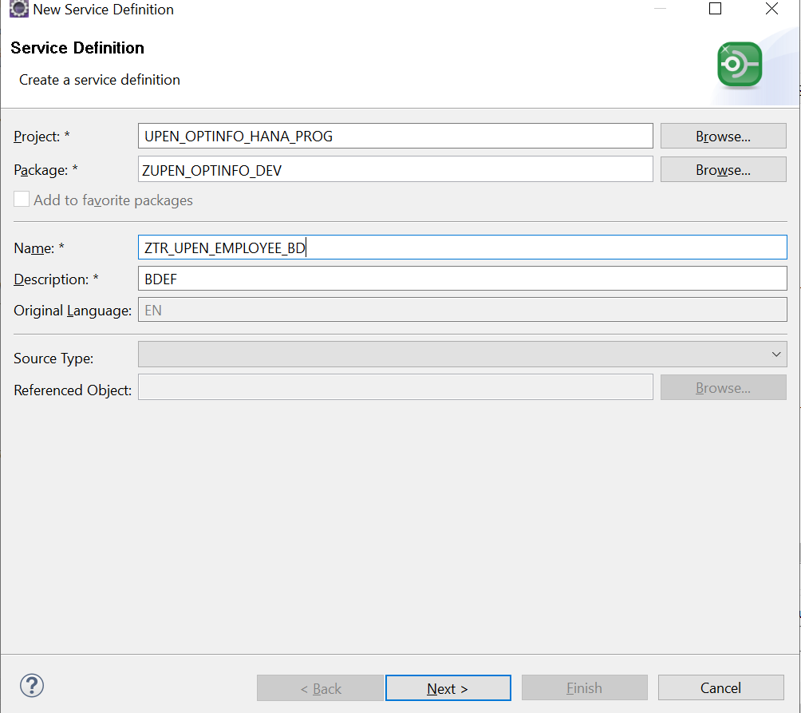

SERVICE DEFINITION
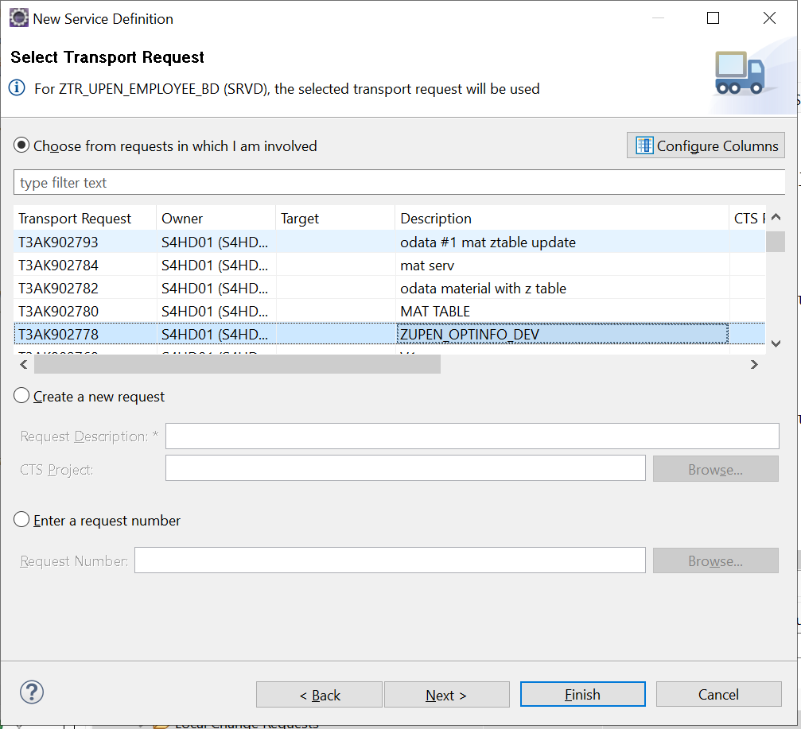
SERVICE BINDING:
